News from the NW Synod 5th October 2016

1: Moderators snapshot
2: News from Heald Green
3: News from Luther King House
4: Carve a Heart
5: News from Kendal - Rinteln Choir
6: Pilots at Synod
7: Flag pastorate Elders ‘Away Day’
8 News from Union Church Hyde

1: Moderators snapshot
Q: who is the “Synod”?
A: (a) us. Every member of every congregation as part of a partnership of 136 churches bearing the light of Christ in those places, but supporting one another in prayer.
A: (b) us. The resources we hold in common (people, buildings, finances) which we share to support one another in 136 communities which need to know Jesus Christ lives today.
A: (c) the Office based at Patricroft URC. This week’s snapshot (not willingly given up!) shows the 4 people who are employed either full or part time to carry out specific roles on our behalf, with some of those we as Synod have elected to serve the life of the Synod in a voluntary capacity in particular roles. So from left to right Tony Rutherford [Finance Officer], Kath Fowler [Legal & Trust Officer], John Rea (elected by Synod as Vice-Chair of Trust and known to many of you for his service in property matters), Hazel Wall [PA, and Hazel is often the person you will speak to on the phone], Kerry Later [Assistant part time secretary], Brian Jolly (nominated to serve us as Clerk-elect), John Piper (elected by us to serve as Synod Treasurer), and Jean Mullineux (again, elected to serve us as Chair of the Synod Trust). Some of you will spot that we are missing Leo Roberts [employed as our CYDO, and Safeguarding] from the picture also.
A: (d) the Area & Synod Pastoral Committees, Learning & Ministries Committee and more - who are all composed of members from our congregations and ministers who willingly offer their time to support the life and witness of our congregations.
Please pray for:
- the staff who are working hard in the Office and visiting churches when needed to support the life of our Synod
- those who serve us on the various committees, as together we support the mission of our congregations
- our Synod gathering this Saturday at Worsley Road URC and the decisions it will make concerning the way will enable and support the development of all God’s People

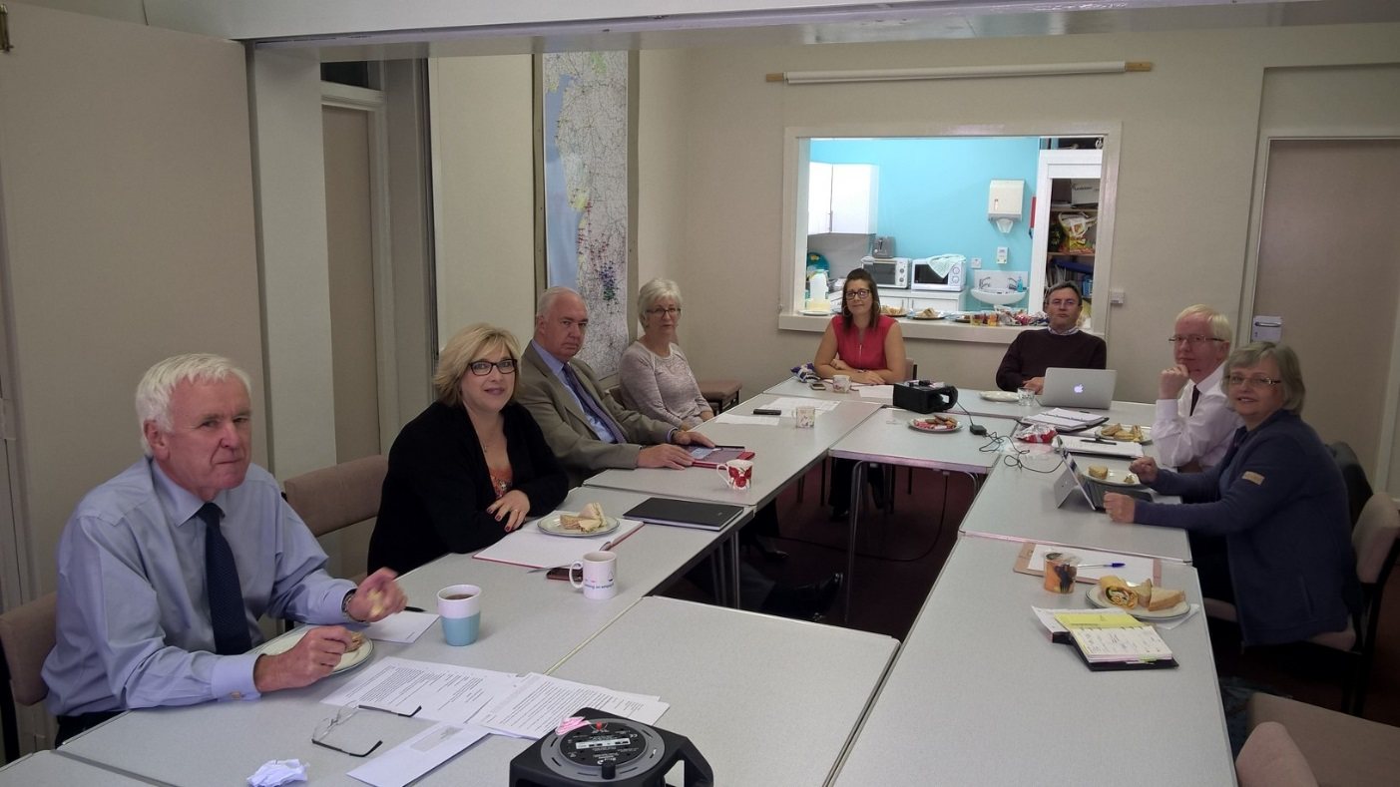

2: News from Heald Green Yesterday, at Heald Green United Reformed Church we celebrated several things. Last year we brought six people into membership by profession of faith, this year we welcomed seven people into membership by transfer. We are so pleased that during a vacancy, we can welcome so many committed people into membership, and pray that our congregation will continue to thrive, supporting each other in faith.
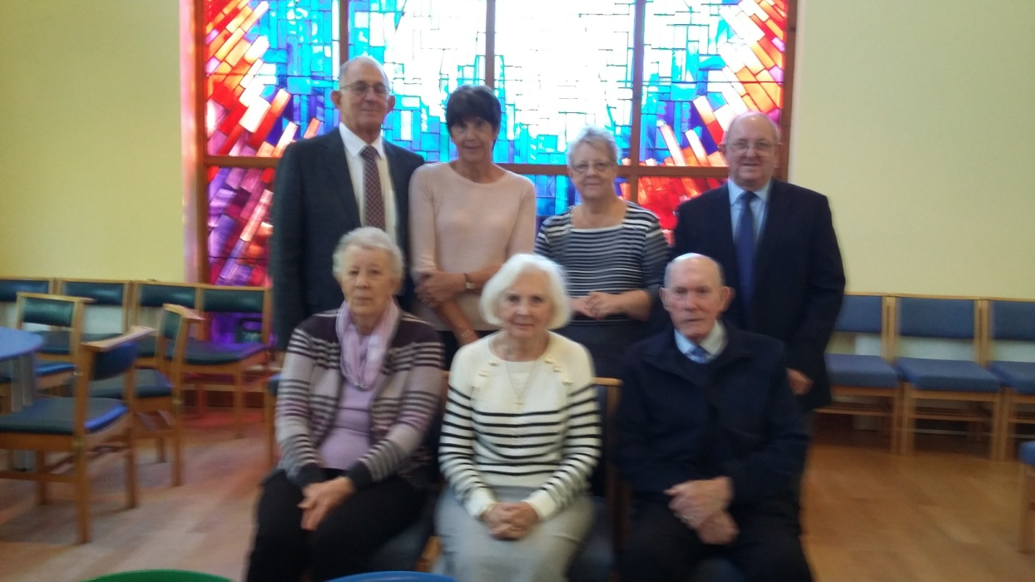
We also welcomed Andy Braunston to his first service with us, as he works with us and Gatley for his final placement. We all wish him well and look forward to all he has to offer.

3: News from Luther King House
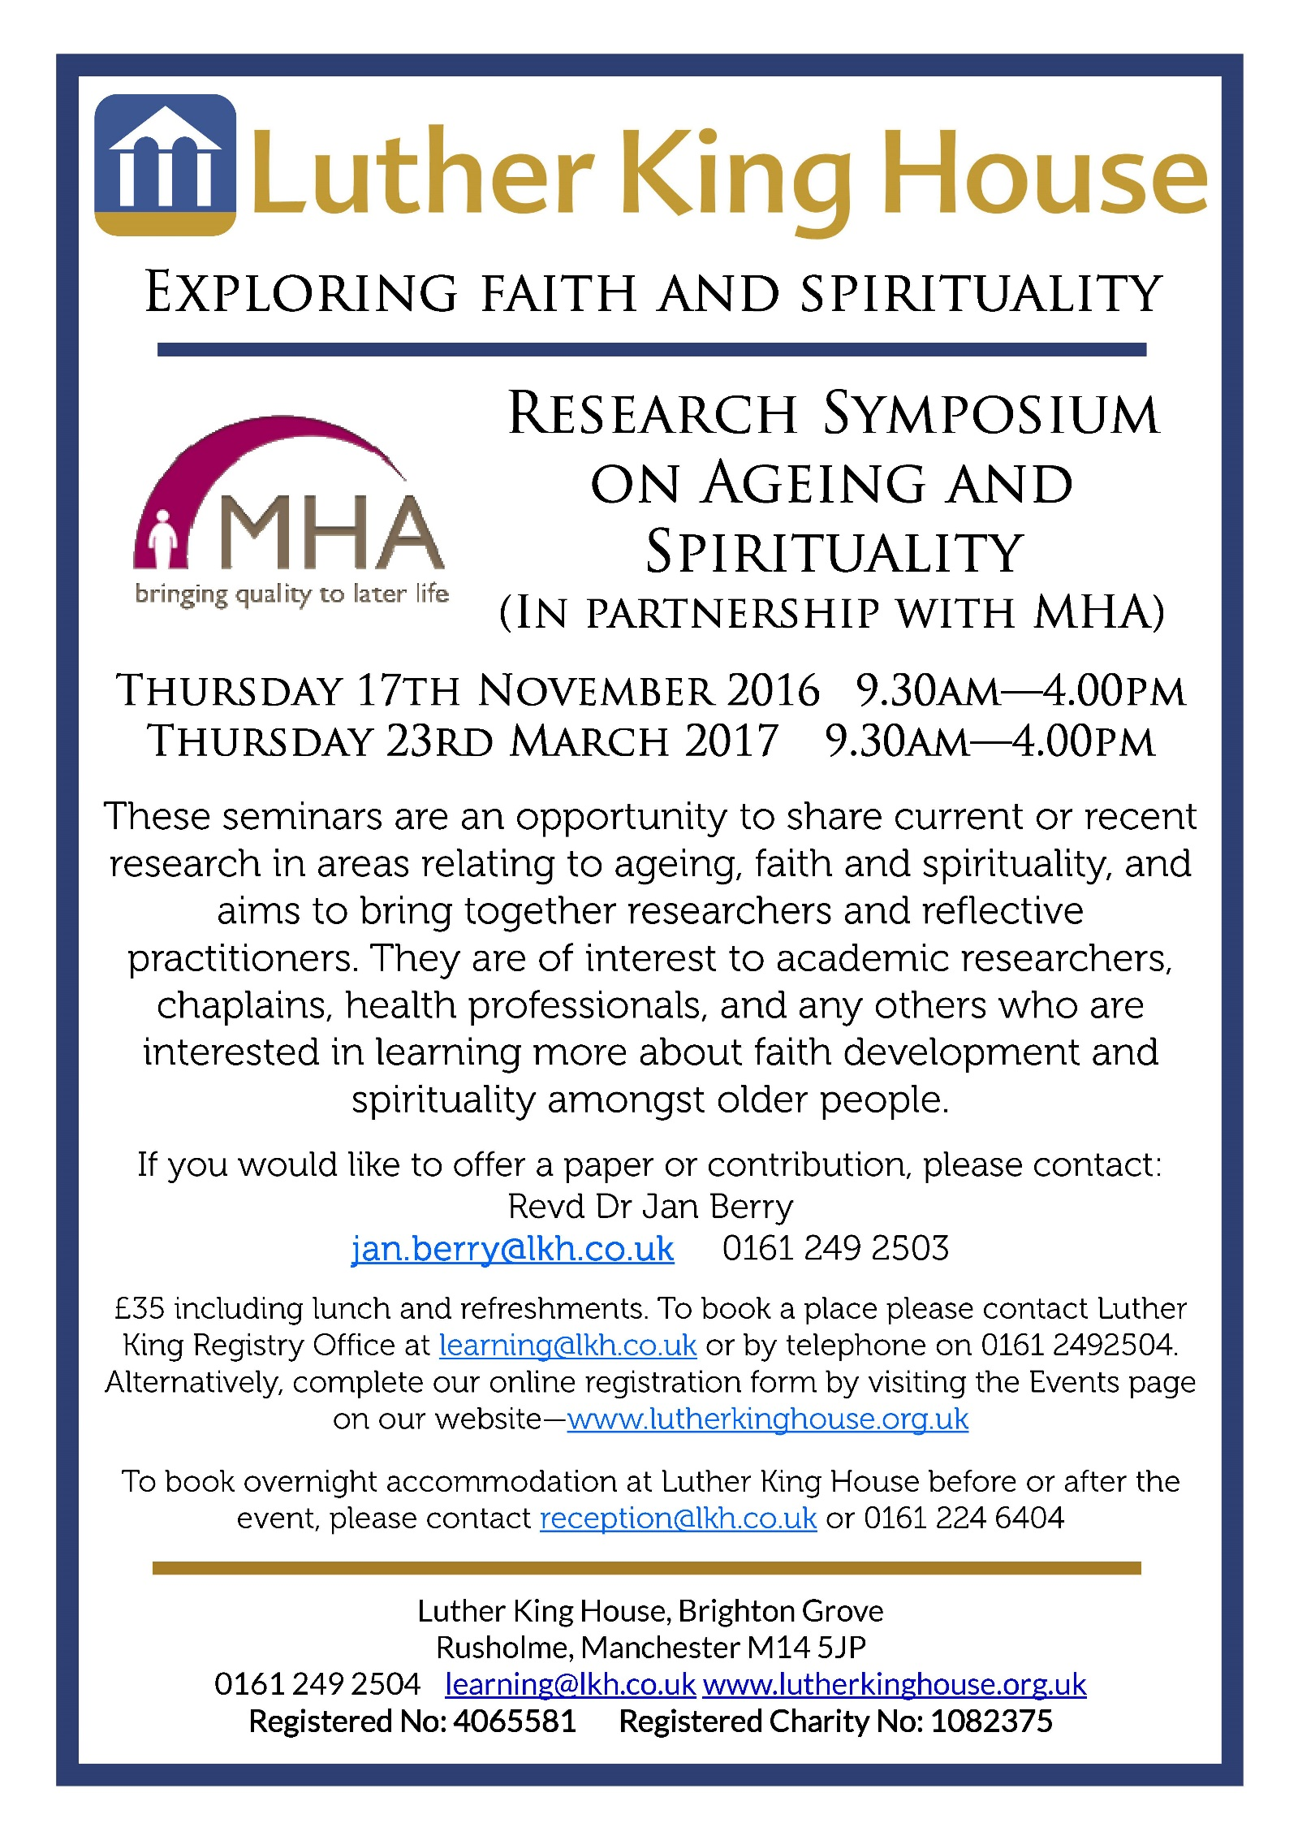
4: Carve a Heart
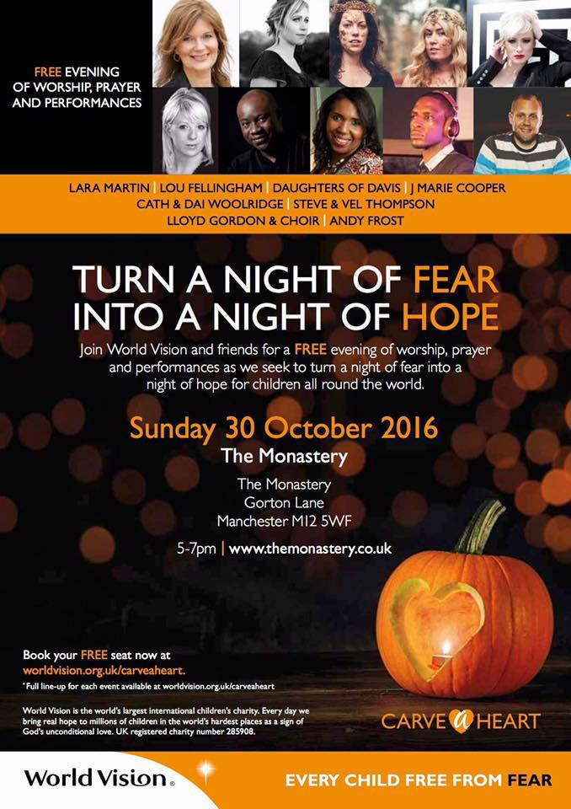
5: News from Kendal - Rinteln Choir Kendal URC was privileged to have the Gospel Choir from Rinteln, Germany, as part of the town`s twinning programme, take part in our morning worship on Sunday.
They set the scene through singing as an introit "Come into His presence"
During the service our hearts were inspired as they sang "Glory to God in the highest" and "Praise the Almighty." Following the Benediction, their rendering of "May the Lord send Angels" brought our worship to a fitting climax.
Our theme for the morning unsurprisingly was "Worship", reflecting together on two hymns of praise in the Bible. It was moving to celebrate Communion with those from another country and different traditions - truly symbolic of our unity in Christ as well as those locals who had joined us for the occasion.
The congregation were encouraged and inspired by the choir`s presence and singing and look forward to welcoming them another time.

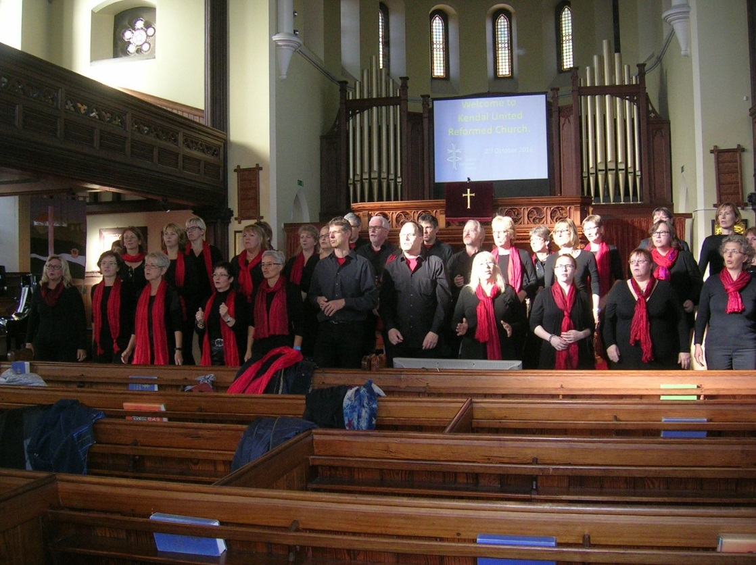

6: Pilots at Synod This is a last call for anyone thinking about bringing children to Synod on Saturday to take part in a ‘Pilots Day’.
PLEASE email cydo@nwsynod.org.uk to confirm places and to ensure that we have enough resources.
At the moment we are under-subscribed so please think about whether some of the children (5-12 years old) in your church might enjoy a day full of activities with other children and bring them along.

Hotpot Training
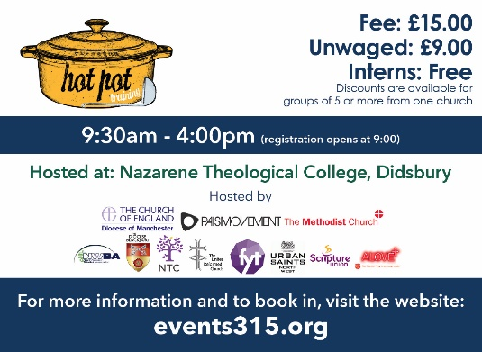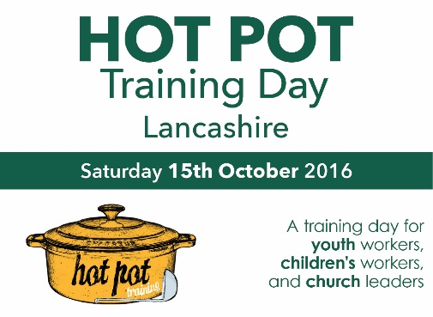
A training day for those who work with children and young people – being he;d in two venues on different days:
Preston: 16th October
Manchester: 12th November
For details of the workshops, venues and cost please visit http://www.events315.org/hot-pot-training-events

7: Flag pastorate Elders ‘Away Day’ On October the 1st the Elders of the Flag Pastorate met at Forton URC for one of their away days. These are fellowship days to enable the Elders to meet, get to know each other, with a Bible study to discuss. The morning is rounded off by a Jacobs Join lunch. Everyone enjoyed bouncing ideas and seeing the Pastorate through each other’s eyes.
Thanks to the Elders and members of Forton URC for their hospitality.
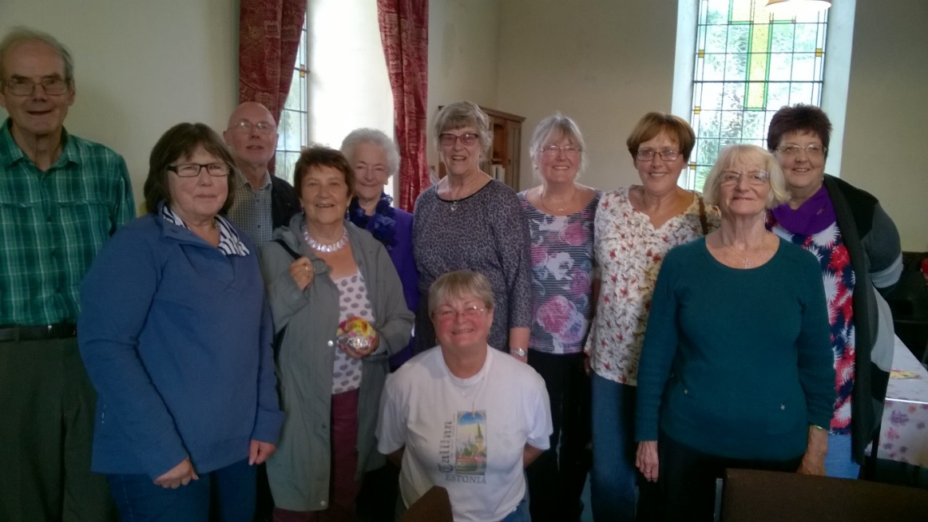

8: News from Union Church Hyde Saturday 24th September was a great day at the United Church, Hyde. The church is a joint Baptist and URC congregation, and the event was to celebrate the arrival of the Rev Marion Pengelly-Phillips as the church’s new full-time Baptist Minister, and to induct her into the pastorate. The church was well-filled with more than 80 in the congregation, including the church’s own membership and visitors from Marion’s former church, along with support from other local churches in the Hyde area. The preacher was the Rev Tim Presswood, the Transitional Regional Minister of the North West Baptist Association. It was good that the Rev Stuart Nixon was able to represent the URC on the day, because Stuart spent a year of his ministerial training at Hyde, and has been a great friend and supporter of the church ever since. The service was actually led by the church’s own lay-preaching team, with contributions from the Trustees and the young people, and the singing was led by the worship group. The afternoon was a great time of joy, worship, thanksgiving, commitment... and fun! Yes, an induction really can be fun, and we think that God will have smiled at quite a lot of what went on! Then, the following weekend, Marion’s husband Bob was received into membership.
But of course it is about so much more than just one great afternoon. It was a great afternoon, yes, but the church really believes that the day marked the start of something big. Marion’s young granddaughters actually set the scene as they started the service with a lively rendering of “Build Your Kingdom” and this is the call to which Marion had responded: to work with a small but determined church to build God’s Kingdom in all sorts of ways, to make church properly relevant to the people who at the moment feel that neither the church nor God is relevant in their lives.
Stephen Cornish, Secretary

