News from the NW Synod 21st September 2016

The Synod meeting in October will be held at Swinton URC Worsley Road Manchester M27 0AG on the 8th October starting at 10.30am. Book of reports to follow shortly

1: Moderators snapshot
2: Office for Counter-Extremism - Open hate crime funding schemes
3: Free Freshers' Packs and 'Going to Uni' Guides
4: Pilots at Synod
5: The Breightmet Talent Event at Red Lane church
6: Heritage Open Weekend at Bramhall United Reformed Church
7: Harvest Party
8: TLS LITE Course
9: Tony Vino comedy event at The Triangle Church
10: Bolton Town Centre Chaplaincy
11: How can we welcome Refuges and Asylum Seekers?
12: Modern Slavery meeting notes 8 September 2016

1: Moderators snapshot This week the five Moderators of the northerly Synods met in Windemere for a day (from left to right myself NW Synod; Jacky Embrey, Mersey; Dave Herbert, Northern; Kevin Watson, Yorkshire and also Moderator of General Assembly for 2 years; David Pickering, Scotland). The URC Synods are divided into 3 “cell groups” and our five Synods form the northerly group. Our meeting together several times a year contributes to our working together across the Synods in different ways, which is already enabling us to share gifts and resources in fruitful ways for the life of the Kingdom at work in our congregations.
Please continue to pray for
- the northerly Synod conversations at which we are represented (next meeting in November) for exploring new ways in which we can work together and share precious resources
- the Moderators as they build relationships together (both the Northern and Scotland Moderators are new in post this summer)
- the Revd Kevin Watson in his work for the General Assembly, and for others in the Yorkshire Synod who are helping to make his wider working for the denomination possible

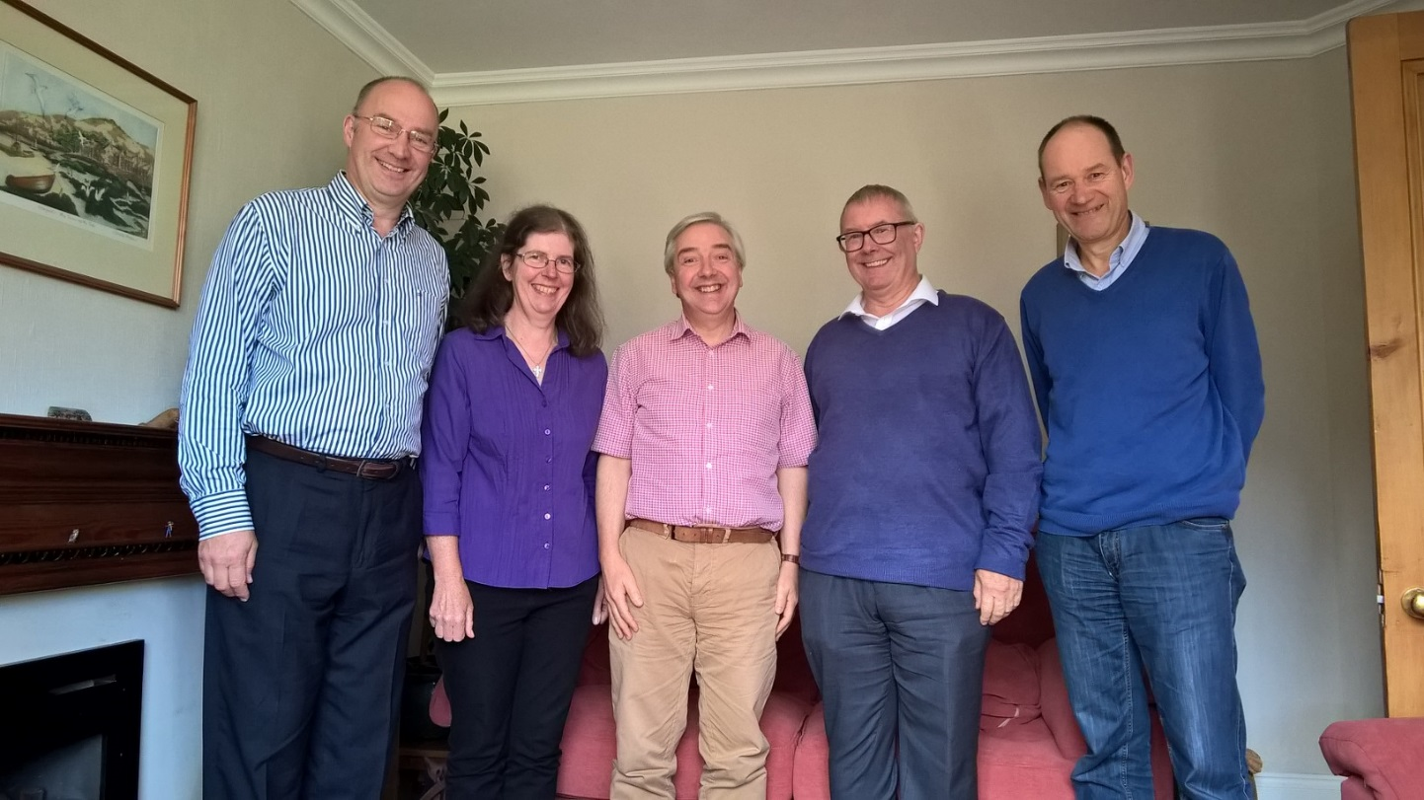
2: Office for Counter-Extremism - Open hate crime funding schemes The Prime Minister has been very clear that hate crime has no place in UK society. We are writing to ensure you are aware of two different funding schemes included within the hate crime action plan that are currently open for bids:
· The Places of Worship Security Funding Scheme will provide protective security measures to places of worship that need increased protection. Bids for funding from places of worship in England and Wales can be submitted until 5pm on 20 September 2016. A second round of bids will open in spring 2017.
· The Hate Crime Community Demonstrations Project Fund will provide funding for community projects that prevent hate crime and issues associated with it. Bids for funding are invited from motivated and creative community groups or consortia to develop innovative programmes. Bids can be submitted until 8pm on 14 October 2016.
For full details on these schemes – including eligibility, how to apply and who to contact if you have any questions – please follow the links above. We hope that you will raise awareness of these schemes amongst places of worship and community groups within your respective local authorities who may be interested in submitting bids, in addition to interested local authority colleagues.
N.B. These schemes outlined above are distinct from the national programme of in-kind and grant support which will be open soon for competitive bids from civil society groups. Further information about the launch of this national programme will follow separately in due course.
Local Delivery Team | Office for Counter-Extremism
Home Office

3: Free Freshers' Packs and 'Going to Uni' Guides Student Christian Movement are offering free fresher’s packs, which include a copy of SCM’s new ‘Going to Uni’ guide, a 42-page booklet covering all the essentials to make the most of university life, from deepening faith and finding a church, to dealing with student culture and finances. Fresher’s packs can be ordered by registering via SCM Connect www.movement.org.uk/scmconnect, or you can email the office on if you'd like to order copies of the 'Going to Uni' guide for your church or youth group."

4: Pilots at Synod
"The best advocates for Pilots in the local church are children who have experienced being Pilots. To create more advocates, the synod Pilots team are putting on a FULL DAY of Pilots activities at the October Synod meeting (8th October, Worsley Road URC). So ask your synod representatives if they would bring a child or two (aged 5-12) from your church with them! The children will be looked after by the synod Pilots team during the morning and afternoon sessions. They'll need to bring their own packed lunch - but drinks and snacks will be provided. If the 'bringers' aren't the parents, they will need to complete a consent form (you can use the one in the latest Good Practice pack from the URC).
We can guarantee that your children will be safe and have a great time playing games, doing craft, praying, learning and thinking about God.
It is important that you book your children's places with cydo@nwsynod.org.uk - as only 40 are available.
Don't let this opportunity go to waste - your children will thank you, and your church might just never be the same again."

5: The Breightmet Talent Event at Red Lane church This event was held to highlight the talents of people in the neighbourhood and was the latest of attempts to bond with our local community. There were no charges for anything - other than the yummy cakes in the tea room which raised £60 for church funds.
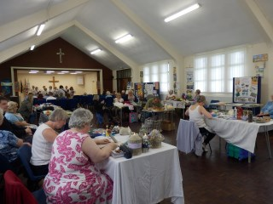
The Breightmet Talent Event was a hive of activity, with the Red Lane Church divided into a section for exhibits and demonstrations and a section for performances. The message was clear – Breightmet can boast plenty of talented people.

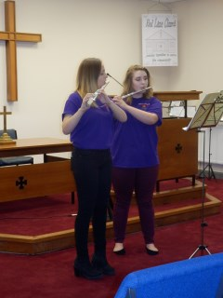
Among the performances featured at the talent event was this flute duet

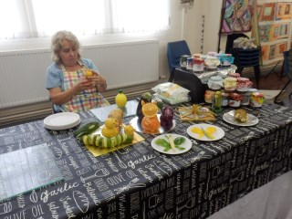
Barbara Pritchard not only makes jam but also has a talent for vegetable sculptures as could be seen by her animal sculptures pictured here.

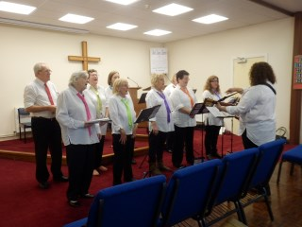
The Breightmet Community Choir opens proceedings at The Breightmet Talent Event.

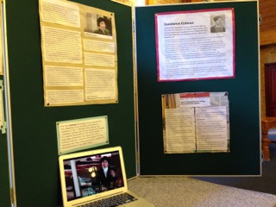
6: Heritage Open Weekend at Bramhall United Reformed Church On Saturday 10th and Sunday 11th September, Bramhall United Reformed Church celebrated the national festival 'Heritage Open Days' by opening our doors for an exhibition of history and heritage.
Displays not only delved into the development and evolution of the site at Robins Lane where Bramhall URC first came to be in 1903, but also of the wider United Reformed Church and it's formation.

Since the Congregational Church and the Presbyterian joined in 1972, the United Reformed Church have been an advocate of forward thinking and have gone a long way to demonstrating that when we say 'Everybody Welcome' - we mean everybody welcome.

We presented history that was ground-breaking at its time; such as the recent motion passed that has allowed the United Reformed Church to become the largest faith group in Britain to allow same-sex marriage ceremonies on its premises.

We also focused on the title that one of the forebears of the United Reformed Church holds: the ordination of the first women in Christian ministry in the UK. Constance Coltman was ordained by the Congregational Union of England and Wales at the Kings Weigh House, London, on 17th September 1917. We showed the film 'Constance' – a production by film-maker Kevin Synman that forms part of the preparation for the celebration of the centenary of Constance's ordination in 2017. He says about the film; “Constance's journey was one of profound character, conviction and courage. Her story resonates with those facing discrimination, prejudice and misunderstanding in the Church today.”

The weekend was rounded off with a 'Songs of Praise' event; an evening of singing and reminiscing about some of our favourite hymns and worship songs. It was a weekend of celebrating our fantastic heritage as part of the United Reformed Church.

Louise Everett

7: Harvest Party
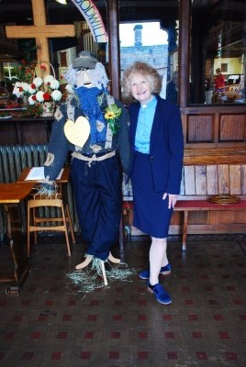
Kendal Church and halls were a hive of activity on 18th September.
The congregation invited those who come to various activities at the church but not to worship, to its Harvest Thanksgiving Service followed by lunch and a party. We were conscious that the biblical harvest is about joyful thanksgiving and sharing with the poor and vulnerable of society and so we endeavoured not only to give, (to the local foodbank and to Tearfund for its work in Uganda) but to celebrate God`s goodness to us.

We are delighted that so many accepted our invitation and some of our more elderly members made a special effort to be there. We also welcomed visitors who were on their way home to Scotland and others who are looking for a spiritual home.

The lunch was simple – soup and roll, followed by a wide range of deserts and tea. The conversations flowed freely. After lunch there was a range of harvest themed quizzes and games, including guess the number of beans, the number of fir cones, the weight of a giant marrow, ducking for apples and skittles.

Our time together concluded with singing some of the older and well-loved harvest hymns and an invite to our next (Christmas) party – Carols by candlelight and a promised welcome at all our various activities.

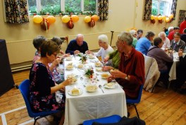
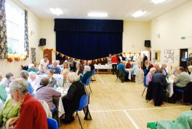

8: TLS LITE Course This week, a group of 8 people from the two congregations which comprise Wilbraham St Ninian’s URC in Chorlton, Manchester, began the TLS LITE course under the tutelage of Revd Mike Walsh, beginning with the first, introductory module – “You, The Bible, God and Worship”. The TLS LITE stands for “Training for Learning and Service – Local Introductory Training Experiences”. The full course comprises at least five of six available modules, and the group will work their way through these over the next year. The people on the course shared their reasons for joining the course, including: deepening their own faith and understanding of the Bible; broadening and enhancing their skills in leading worship; and, working towards Synod recognition as a lay preacher.

9: Tony Vino comedy event at The Triangle Church

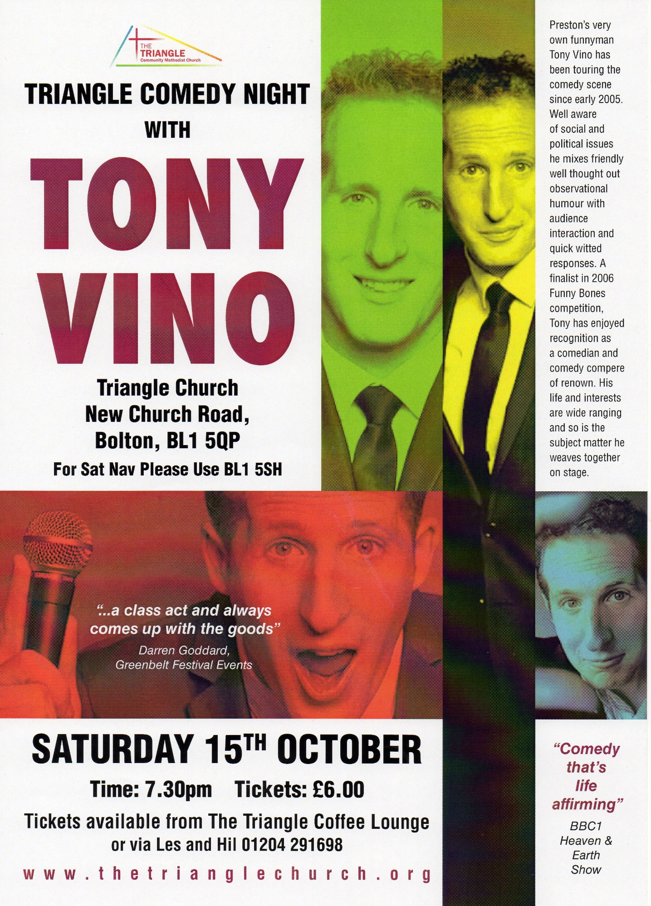

10: Bolton Town Centre Chaplaincy

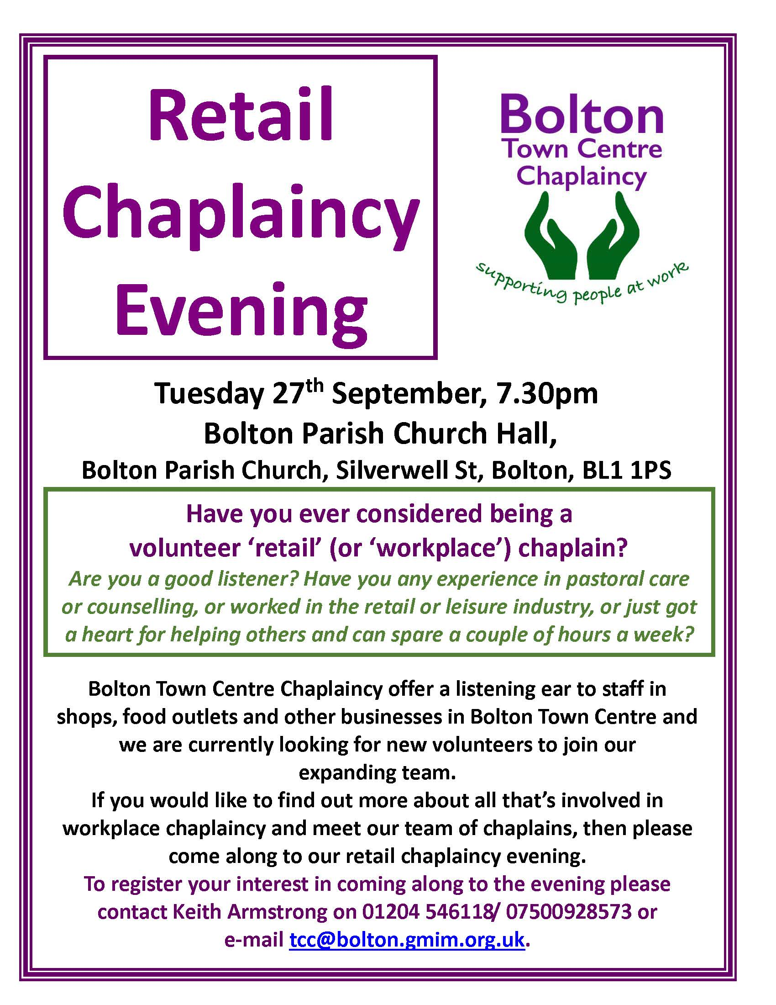

11: How can we welcome Refuges and Asylum Seekers?

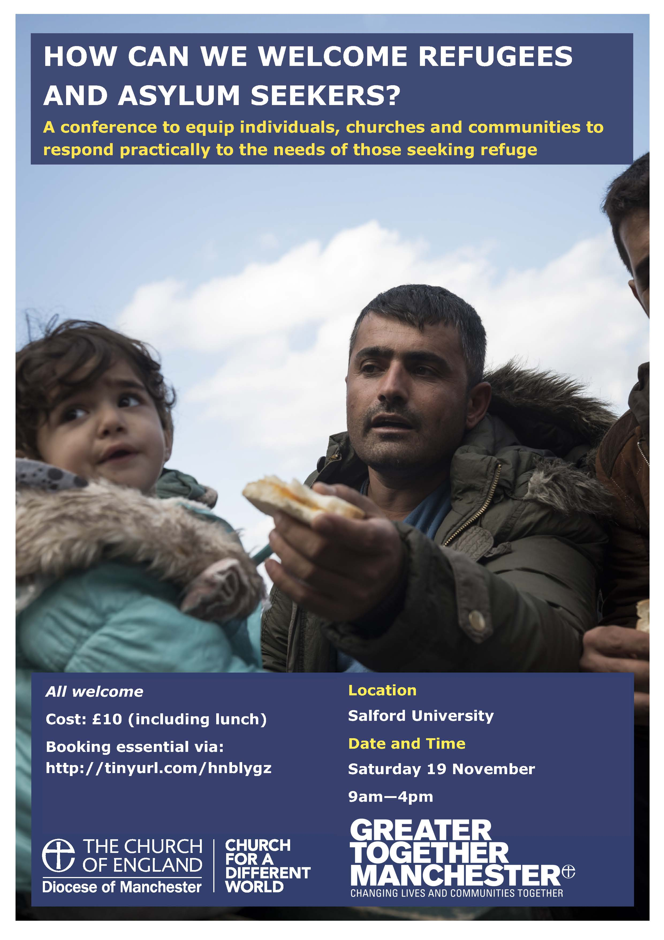

12: Modern Slavery meeting 8 September 2016 This meeting was a planning session for the forthcoming PUBLIC EVENT to be held at Manchester Cathedral on Monday 7 November 2016 from 2.00pm-4.30pm. Please save the date in your diaries.
An Event Brite invitation will be circulated soon and we ask that you please share this as widely as possible amongst your networks.

