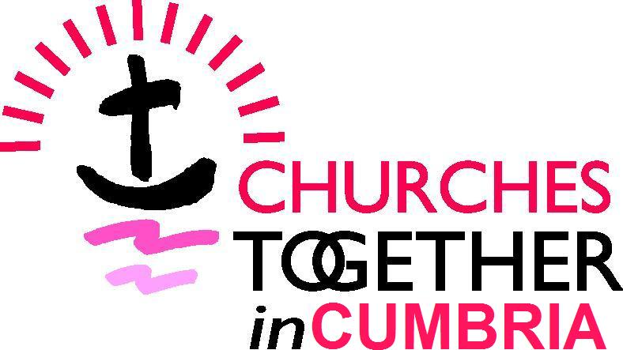
CELEBRATING TOGETHER 2016
CELEBRATING TOGETHER 2015
CELEBRATING TOGETHER 2015

Booking Form:
Rooted and Grounded in Love: a prayer taster day

St Mary’s Church & Ambleside Church Centre, Ambleside, LA22 9DH
Saturday 17 September 2016; 10am – 4pm

Names & churches / organisations of those attending:

…………………………………………………………………………………………..

…………………………………………………………………………………………..

…………………………………………………………………………………………..

…………………………………………………………………………………………..

Email addresses: (or postal address if no email)

…………………………………………………………………………………………..

…………………………………………………………………………………………..

…………………………………………………………………………………………..

…………………………………………………………………………………………..

Cost £12 (please notify us if reduced rate needed)
CTiC prefers payment by BACS if possible. CTiC account details:
Sort code: 30-91-66 Account no: 00510174
For a reference please use CT2016 & your surname

I have made a BACS transfer

I enclose cheque made payable to Churches Together in Cumbria

Email to: hbctic@tiscali.co.uk or lkctic@yahoo.com (BACS payments)
Post to: Helen Boothroyd, CTiC, 46 Oak Avenue, Morecambe, LA4 6HS (cheques)

Cumbria Church Leader Workshop – please state 1st and 2nd preference

An opportunity to hear about the faith journey of one of our Church Leaders.

Bishop James Newcome – Bishop of Carlisle

Father John Musther – Priest of the Orthodox Church in Cumbria

Major Drew McCombe – Salvation Army NW Divisional Leader

Reverend Richard Teal – Chair Cumbria Methodist District

Bill Bewley – Religious Society of Friends (Quakers)

Afternoon Workshops – these will be run twice so please rank (1-5) your preferences with 1 as your preferred workshop.

Praying with Music: Kath Dodd
Discover how instrumental music can be used as an integral part of prayer, rather than as a gentle backdrop to prayer. The Psalms express many different emotions, and these can be matched with the emotional impact of a piece of music. Here the music will consist of ‘live’ classical piano music, interspersed with silence for personal prayer and reflection.

Prayer Stations - Creative Reflective Spaces: Pauline West
This workshop will explore ways of designing and constructing creative spaces for personal reflection: deciding the purpose of the display; how to obtain ideas and themes; materials that can be used and how they help; constructing the display; encouraging interaction.

Christian Meditation: Richard Broughton
Every follower of Jesus is called to be a contemplative. For the contemplative, Christian prayer is not, essentially, speaking to God, or thinking about God. It is about entering into a silent conversation with God through the mind of Christ. We will talk briefly about this and then spend some time in silence together, with space for sharing at the end.

Emotion and Spirituality: Alison Mesher
In this workshop we will be: exploring the emotional basis of our choices and behaviour; de-mystifying emotion; and understanding how we can grow beyond our emotional reasoning, in order to live and act from a ground of being that is rooted and grounded securely in God's love in Christ. The workshop will present insights from neuroscience - helping us to grasp the emotional brain - and consider the role of spirituality and spiritual disciplines as tools that enable us to master emotions, rather than be mastered by them as we experience the mind of Christ.

Exploring and Experiencing Celtic Spirituality: Cameron Butland
Celtic Spirituality seeks to discern God in and through creation. This workshop looks at the distinctive features of this form of spirituality including the role of community and different forms of prayers, such as Circle prayers. Using images, prayers and readings the workshop will conclude with a short period of reflection.

